_______________________________________________________________________

**CSC121 PYTHON Programming**

_______________________________________________________________________

LAB 08 **FUNCTIONS [PART 2]**

# Objectives

In this lab assignment, students will learn:

- What value-returning functions are and how to write them

- What return values are and how to send and receive them

- How to send multiple return values

- How to receive multiple return values

# Goals

In this lab assignment, students will demonstrate the abilities to:

- write value-returning functions

- write code to send and receive return values

- write code to send multiple return values

- write code to receive multiple return values

# Instruction and Problems

Write a Python program for each of the problems in this lab. Please use PyCharm to type and test your programs. Submit the Python files to Blackboard for credit. In this lab, you should submit 4 Python files, one for each problem.

## Problem 1

In Lab 07 we wrote a program to calculate energy bill for households. We are going to rewrite that program with value returning functions. Energy consumption is measured in kilowatt hours (kWh). The more kWh a household use in a month, the higher the energy bill. A power company charges customers $0.12 per kWh for the first 500 kWh. After the first 500 kWh, the rate is $0.15 per kWh. Write a program to calculate energy charge. You must write and use the following functions.

1. A main function: Call the value returning function get_kWh_used. Pass the return value to the value returning function bill_calculator as an argument. Display the return value of bill_calculator.
2. A get_kWh_used function: This function has no parameter. It asks the user to enter number of kWh used. Use an input validation loop to ensure that kWh used is not negative. Return kWh used.
3. A bill_calculator function: This function has a parameter to receive number of kWh used. Calculate and return the energy charge.

The following is an example.

Enter kilowatt hours used: -5

kWh cannot be negative.

Enter kilowatt hours used: -6

kWh cannot be negative.

Enter kilowatt hours used: 510

Please pay this amount: 61.5

Save your Python program in a file named **Lab08P1.py**. Submit the file to Blackboard for credit.

## Problem 2

In Lab 07 we wrote a program to calculate energy bill for residential and business customers. We are going to rewrite that program with value returning functions. Residential customers pay $0.12 per kWh for the first 500 kWh. After the first 500 kWh, the rate is $0.15 per kWh. Business customers pay $0.16 per kWh for the first 800 kWh. After the first 800 kWh, the rate is $0.20 per kWh. Write a program to calculate energy charge. You must write and use the following functions.

1. A main function: Call the value returning function get_user_input, which returns kWh used and customer type. Pass the return values to the value returning function bill_calculator as two arguments. Display the return value of bill_calculator.
2. A get_user_input function: This function has no parameter. It asks the user to enter number of kWh used. Use an input validation loop to ensure that kWh used is not negative. Also ask the user to enter customer type (enter R for residential or B for business). Convert lowercase letter to uppercase. Use an input validation loop to ensure that customer is either R or B. Return kWh used and customer type.
3. A bill_calculator function: This function has two parameters to receive number of kWh used and customer type. Calculate and return the energy charge.

The following is an example.

Enter kilowatt hours used: -5

kWh cannot be negative.

Enter kilowatt hours used: -6

kWh cannot be negative.

Enter kilowatt hours used: 510

Enter R for residential customer, B for business customer: x

Invalid customer type.

Enter R for residential customer, B for business customer: y

Invalid customer type.

Enter R for residential customer, B for business customer: r

Please pay this amount: 61.5

Save your Python program in a file named **Lab08P2.py**. Submit the file to Blackboard for credit.

## Problem 3

The following program uses a loop to create a list of odd integers, whose range depends on user's choice:

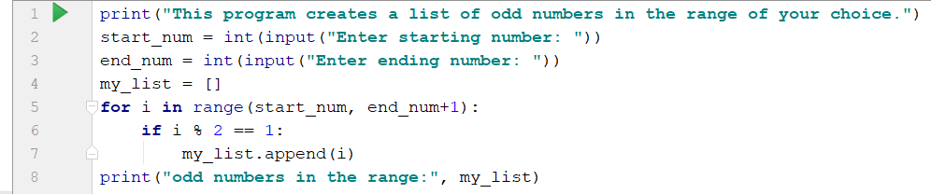

We can shorten the program by using generator expression. Use one single statement to replace line 4 through line 7. You must use generator expression in that statement.

The following is an example.

This program creates a list of odd numbers in the range of your choice.

Enter starting number: 11

Enter ending number: 21

Odd numbers in the range: [11, 13, 15, 17, 19, 21]

Save your Python program in a file named **Lab08P3.py**. Submit the file to Blackboard for credit.

## Problem 4

In the following program, a function average is defined to calculate the average of the elements of a list. This function is called twice to calculate two averages.

**def** average (my_list) :  
 avg = sum(my_list)/len(my_list)  
 **return** avg  
  
list1 = [2, 1, 5, 9, 8]  
list1_avg = average(list1)  
print(**"list1 average:"**, list1_avg)  
list2 = [17, 5, 2, 4]  
list2_avg = average(list2)  
print(**"list2 average:"**, list2_avg)

Rewrite the program by replacing the definition of function average with a lambda function. That means in your program there should be no function definition using the keyword def.

The following is the expected output.

list1 average: 5.0

list2 average: 7.0

Save your Python program in a file named **Lab08P4.py**. Submit the file to Blackboard for credit.

# Grading rubric for Program 1

Writing main function [10 points]

Writing get_kWh_used function [10 points]

Writing bill_calculator function [10 points]

# Grading rubric for Program 2

Writing main function [10 points]

Writing get_user_input function [10 points]

Writing bill_calculator function [10 points]

# Grading rubric for Program 3

Using generator expression [20 points]

# Grading rubric for Program 4

Using lambda function [20 points]